I’m Craig Connell, UX Designer.
I focus on product usability and business growth.

And I’d like to work with you.

Introduc7on

Design is why I’m eternally watching, testing, reading, experiencing; frameworks, workflows, tools, ideas. Design is psychology, emotion, simplicity, life. Great design is uncomplicated, understandable, drives outcomes and delivers results. Great design is pleasureable, and rewarding. Great design is what strive for, great design drives me.

I’ve had clients across ﬁnance, travel, entertainment, media, retail, sport, and healthcare. I love adver@sing, marke@ng, copywri@ng and coding, using each when required and working to bridge those teams in commercial environments.

Art is for enjoyment, but I design for purpose. I design for business, I design for people.

Skillsets

+ Agile / Scrum
+ Lean UX / Iterative design approach
+ User testing and research
+ Personas, user stories, card sorting
+ Heuristic Analysis & Evaluation
+ Developing proposals, style guides and briefs
+ Encouraging leader
+ Empathy for developers & dependants
+ Abreast of new technology and practices
+ Enjoy complex, multi-discipline projects
+ Confident liaising with stakeholders
+ Structured and led design workshops

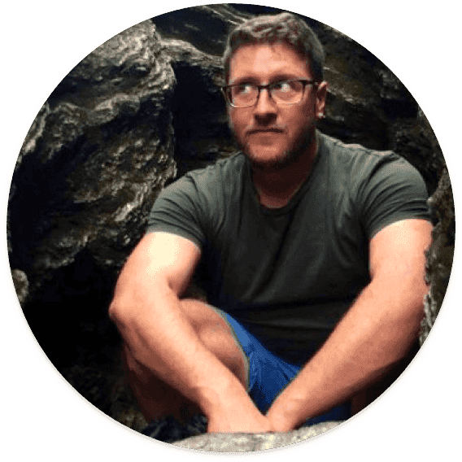

Recent Projects >

Recent Projects

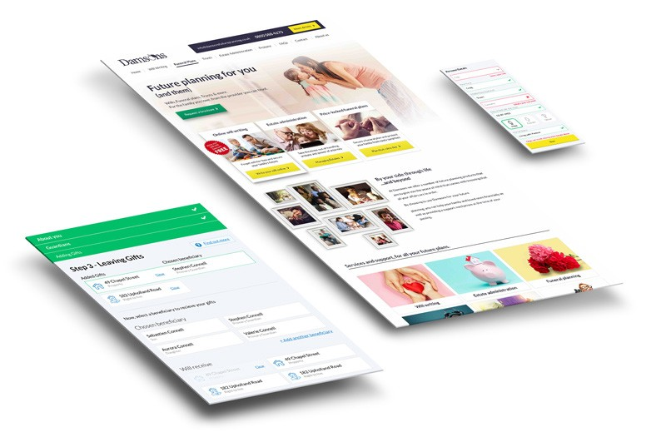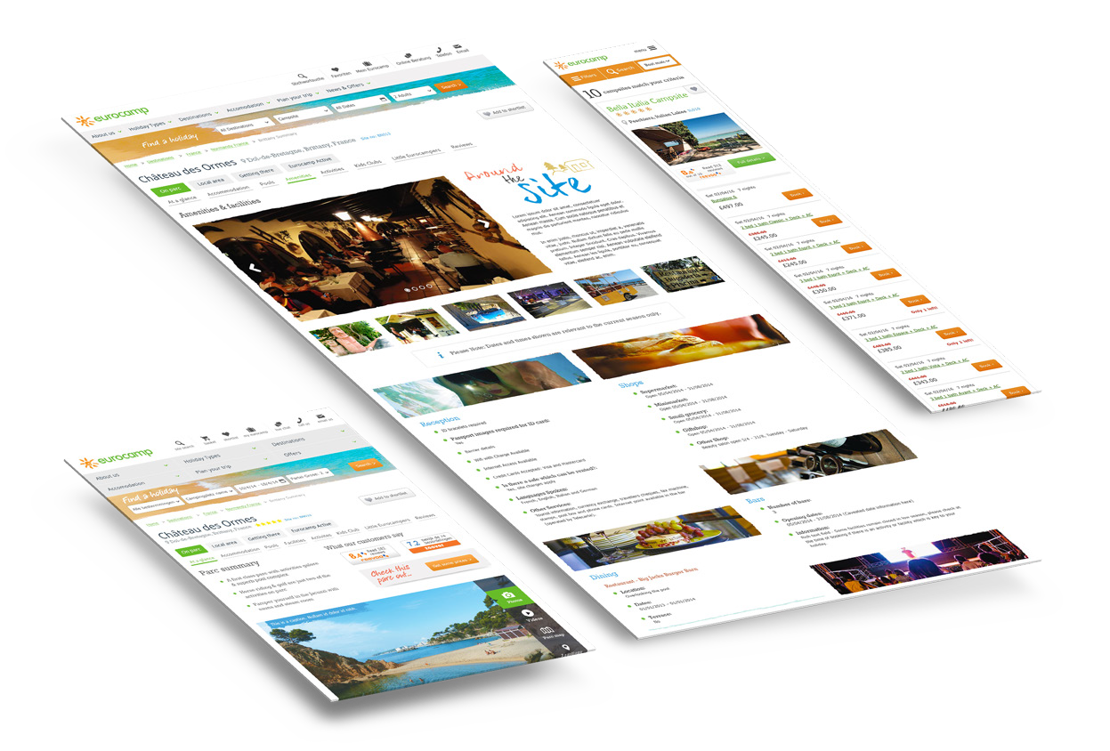

Damsons Future Planning
+ Led re-brand across digital and print
+ Designed product & user journey for mobile and desktop
+ Rapid Prototypes for user testing
+ Hi-fidelity prototypes for stakeholder approval
+ Continued remote user testing for iterative improvement
+ A/B & Split testing
+ PPC Landing page design & build. Email design, build & optimisation

Eurocamp
+ Large scale, e-commerce re-design
+ User research, personas and wireframes
+ Implemented new image across seven European markets
+ Designed and wrote style guide for use by remote content teams
+ Led QA test team. Ran workshops and ideas sessions for stakeholders and team members

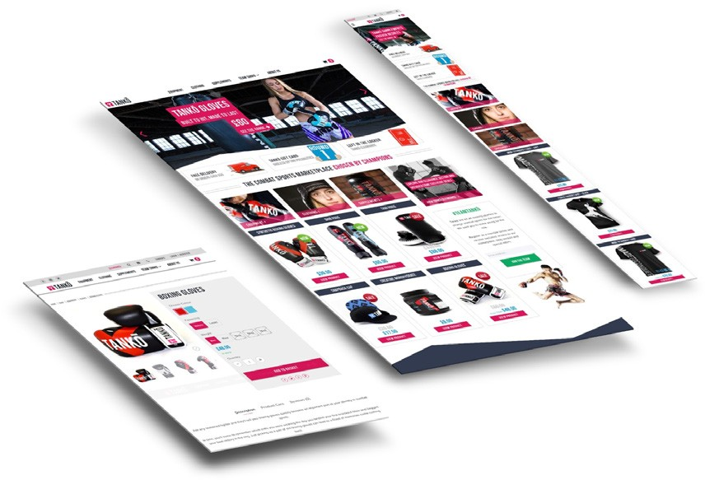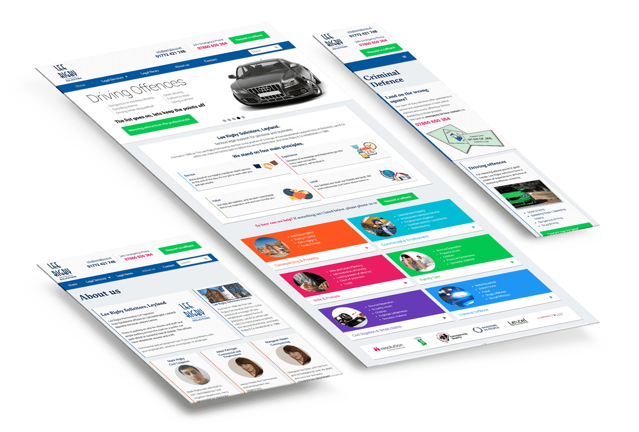

Tanko
+ Responsive e-commerce website design
+ Branding and design approach
+ Digital & Print graphics for website and Tanko events
+ Remote user testing
+ Iterative improvements to design, layout, product and checkout areas
+ Server, SEO & optimisation improvements

Lee Rigby
+ Broad, conceptual idea designed through mutiple approval process
+ Responsive design & complete build
+ Invision prototypes for board approval
+ Copywriting of all text
+ Analytics reviews to place higher interest services up front
+ SEO and digital marketing setup

Read more at www.getsomemilk.com Employment >

Employment

Manchester Outsourcing - UX & Design Specialist Feb 2016 - March 2017
Senior position with a Junior Designer & Front-end Developer of my own. Promoted design thinking, lean and agile approaches; encouraged team to take initiative and continuously improve.
A venture building company with business interests of it’s own, this was an agency-style environment, so projects were varied and fast paced. Desigining and testing landing pages for PPC one day, large format graphics for sports brands the next. I oversaw external digital agencies on some projects, leading brand identity and design and UX of the products; while getting my hands dirty at every opportunity.
However, there was also time to work on long term projects, to which I designed numerous digital products for, and was able to utilise my knowledge of UX and conversion optimisation across a wide range of products, with input at board level on most subjects.

Eurocamp - Digital Designer July 2013 - Nov 2015
One of two lead designers for a mobile first, e-commerce shift. Initially an eight week contract, after two years I had implemented a new brand image across 7 markets and designed & written style guides for content teams across Europe. Agile workflows, sprint plans for release (post build), scrum environment.
Led the QA test team and ran workshops for stakeholders and team members. Since completion of the website online sales account for 50% of the business revenue, up from 17%, and has in excess of one million visitors per month.

getsomemilk.com - Freelance Web & Graphic Designer April 2012 - Feb 2016
Wordpress and Photoshop were my tools. Customer usability, experience & conversion my goals. Clients included: Soundbase Megastore, Toast Recordings, G-Style Group, We Love Leeds, Lost & Found, Selectro.

CoMonMouthStudios - Web Designer, MarkePng Manager April 2012 - Jan 2015
Overseeing the day to day business of the studio. Attracting and retaining new clients. Website Design, build & customisation. ongoing in and outbound marketing.

Soundbase Megastore - MarkePng Manager, Graphic Designer April 2012 - Nov 2015
Web Banners, Magazine Adverts, Email Campaigns, Event Flyers and Social Media. Customer service was my focus in the company. Something I pressed into all staff attitudes.

Sodexo Healthcare Ltd - Project Co-ordinator, Graphic Designer August 2007 - Jan 2010
Tender production for High profile NHS Trusts. A professional, extremely thorough approach was imperative. Graphic Design, copy-editing & project management.

Educaton & References >

Educa&on

Manchester Outsourcing - UX & Design Specialist

Futureworks 2007-2009
Applied Audio Engineering & Production - Merit

Avid / Digidesign 2009
Pro Tools Certification in Music & Post-Production - Operator Qualified to levels 210M, 210P & 220M

IDEA 2004
Adobe Illustrator Intermediate Techniques - Merit

Business Skills 2004
Information Technology - GNVQ II - Pass

Wigan & Leigh College 2002
Electronic Engineering - BTEC Nat. Diploma - Pass

St. Peters RC High School 1998
Maths, Science (2), English - Grade C
IT, Business, Technology, French - Grade D

References

Jamie Alaise
Manchester Outsourcing - Managing Director

Philip De Ste Croix
Manchester Outsourcing - Team Manager

Liliana Ashton
Eurocamp e-commerce Director (Now Michelin Consultant)

Lynsey Pritchard
Eurcamp digital Producer
(Now senior project manager at Amaze Ltd)

Simon Lloyd
Lee Rigby Legal - Partner

Reference contact details available on request

Thanks for reading.
Please go to www.getsomemilk.com for more (]
craig@getsomemilk.com 07779439304

