Sub: Bladder cancer detection breakthrough to be featured at <<Facility & event name>>

Learn about the breakthrough technology that improves bladder cancer detection at the <<Insert facility name>> <<Insert event name>>

If you or anyone you know has or is at risk for bladder cancer, this is an important event you won't want to miss!

Join us on <<insert date>> at the <<insert facility & event name>> to learn about the latest health care trends and breakthroughs, including a new technology that increases the detection of bladder cancer.
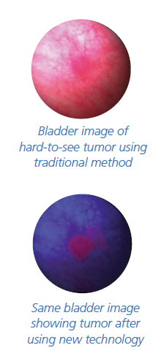

When used along with the traditional method, this new technology:
- Improves detection―so that your doctor can see and remove more cancerous tumors
- Allows better disease management―by removing more tumors

Here's your opportunity to talk to the professionals and learn more about this breakthrough technology! Don't miss it!

<<Insert event name/dates/times>>
<< Insert facility/urologist info>>

