Learn about the breakthrough technology
that improves bladder cancer detection at the
<<Insert facility name>> <<Insert event name>>

Bladder image of hard-to-see tumor using traditional method

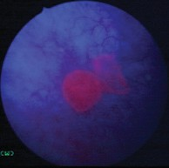

Same bladder image showing tumor after using new technology

If you or anyone you know has or is at risk for bladder cancer, this is an important event you won’t want to miss!
Join us on << Insert date>> at the <<Insert facility & event name>> to learn about the latest health care trends and breakthroughs, including a new technology that increases the detection of bladder cancer.

When used along with the traditional method, this new technology:
• Improves detection—so that your doctor can see and remove more cancerous tumors
• Allows better disease management—by removing more tumors

Here’s your opportunity to talk to the professionals and learn more about this breakthrough technology! Don’t miss it!

<<Insert event name/dates/times>>

<< Insert facility/urologist info>>

For more information, please contact us at <<Insert contact information>>

© 2012 Photocure Inc. All rights reserved. September 2012 CYSC2012020

