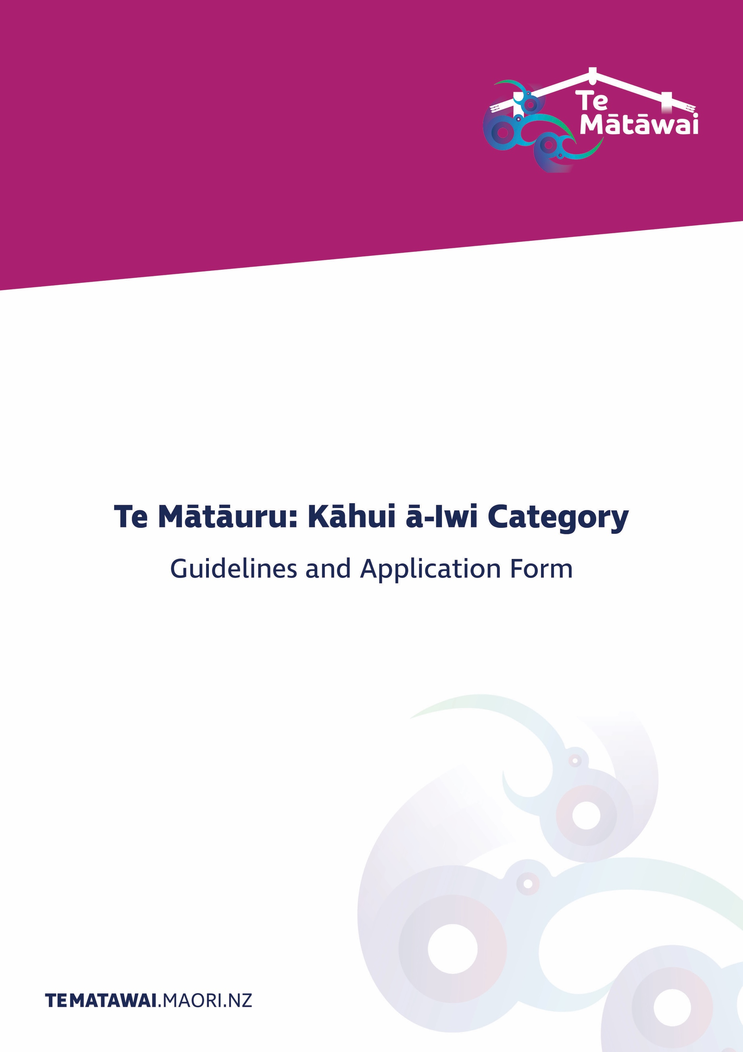

Contents
Section 1: Important information about the Te Mātāuru Kāhui ā-Iwi Category 3
1. Background to Te Mātāuru 3
2. Te Mātāuru Investment Outcomes Framework 3
3. Te Mātāuru Kāhui ā-Iwi Category Criteria 4
4. Who can apply? 4
5. What types of projects qualify for Te Mātāuru Kāhui ā-Iwi Funding 4
6. What types of projects do not qualify for Te Mātāuru Kāhui ā-Iwi Funding 5
7. How much can I apply for? 5
8. How often can I apply and how are decisions made? 5
9. Rights to publish 6
10. Evaluation 6
Section 2: Guide to completing the Application Form 7
11. Some hints to help you 7
12. The Application Form and Checklist 7
13. Timing of the process 8
Section 3: Application Form 9

Section 1: Important information about the Te Mātāuru Kāhui ā-Iwi Category

Background to Te Mātāuru
On 1 July 2017, Te Mātāwai became responsible for administering $10.817 million annually for te reo Māori revitalisation investments in homes and communities. The home and community focussed support is driven by a Cluster or Kāhui Model comprising seven Iwi and one Reo Tukutuku Pae Motuhake.
Te Mātāuru is premised on the Vision: “Kia ukaipo ano te reo – te reo Māori is restored as a nurturing first language.” For a language to be used as a ‘first language’ it needs to be:
• appropriate and relevant to the settings of daily life;
• able to be used in contemporary and diverse contexts and not limited to traditional or ritualistic use;
• supported to evolve and grow of its own accord through active use;
• nurtured naturally in positive whānau and community environments, helping to ensure the language is self-sustaining; and
• accepted throughout New Zealand society as a first language of this country.

Te Mātāuru Investment Outcomes Framework
The following framework has a focus on both incremental and sustainable changes that are dependent on user readiness including the levels of proficiency and awareness.
The framework acknowledges that applicants who seek Te Mātāuru investment support will be at different levels in their te reo Māori revitalisation journey. Applicants are encouraged to use the framework to plot their starting point and the level of development and proficiency they hope to achieve, and importantly how they plan to achieve success.
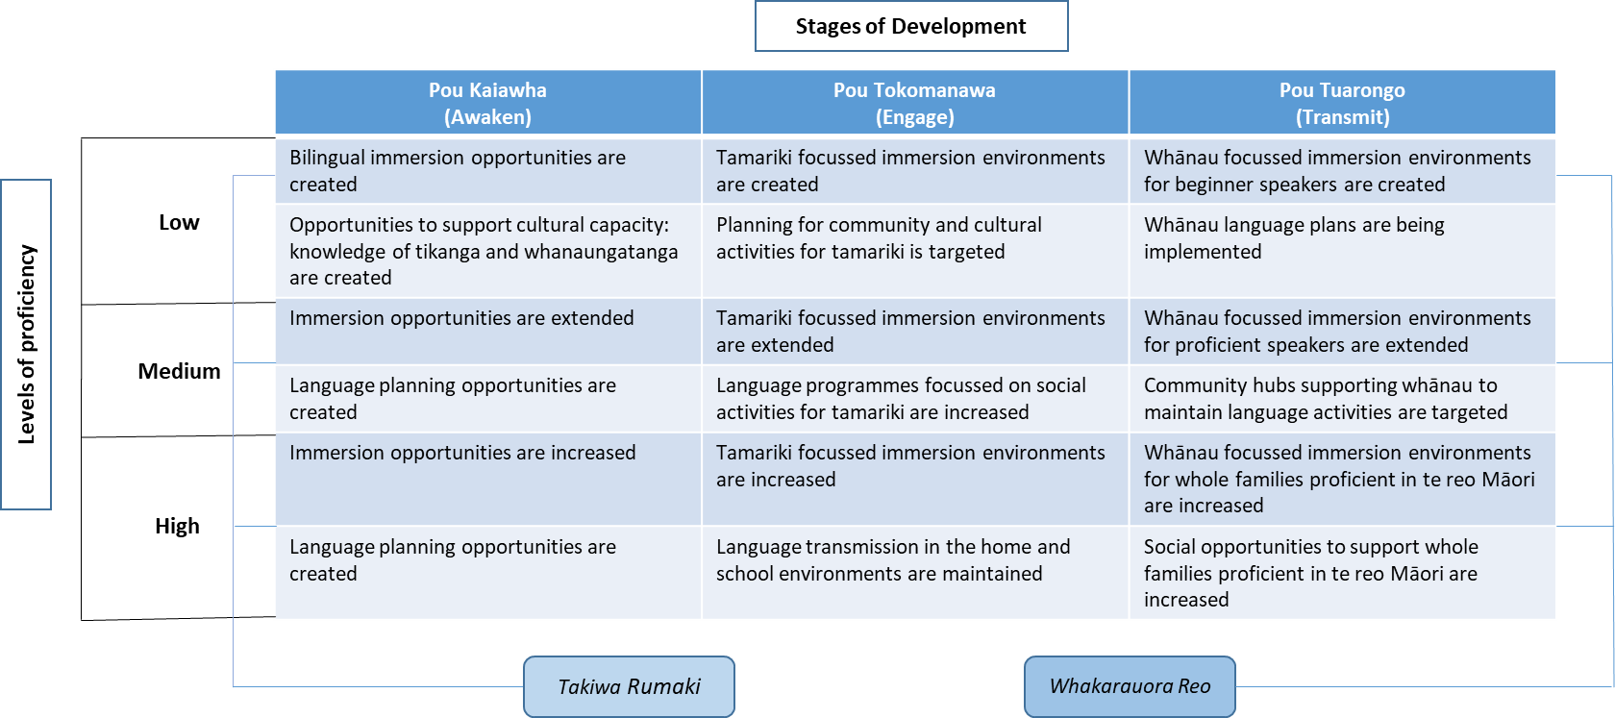

Te Mātāuru Kāhui ā-Iwi Category Criteria
Applications within this category must show how projects will:
- Achieve or contribute to the ‘Stages of Development’ and the ‘Levels of Proficiency’ detailed in the Te Mātāuru Investment Outcomes Framework.
- Contribute to the priorities identified in the Te Pae Motuhake Annual Investment Plan.
- Achieve and/or align to the following:
- The projects or activities of other providers: to demonstrate a joined-up approach that builds local capacity, improves ‘reach’ into communities and develops new projects;
- Better promotion: to improve access to proposed projects;
- Easier access: so that more whānau, hapu and iwi may benefit from te reo Maori revitalisation initiatives;
- Fostering te reo Māori within whānau: to improve the levels of proficiency and awareness;
- Innovation: to try new approaches that yield better outcomes;
- Pilots: that were successfully undertaken locally and could be applied in other regions; and
- Related to broadcasting and education sectors, and hāpori Māori activities, but in a way that is not funded or deemed the role of the Crown.

Who can apply?
Any person or organisation who affiliates to an iwi or hapu listed in Te Ture mō Te Reo Māori 2016 may apply for investment funding under the Te Mātāuru Kāhui ā-Iwi Category.
Note that applicants do not have to be residing in their tribal areas. Applicants must be a New Zealand citizen, permanent resident or an organisation that is based and delivers services in New Zealand.

What types of projects qualify for Te Mātāuru Kāhui ā-Iwi Funding
We are deliberate in our approach and do not specify the activities and projects that may be funded. This is because we want all applicants to think about what they plan to do and what outcomes and changes they want to achieve.
We are interested in the changes you hope to see and we have developed the following questions to guide your thinking and help you to tell your story. While you don’t have to answer every question, you are encouraged to answer as fully as possible.
- We are particularly interested in the people who will benefit from your project. Tell us about them: who they are, what the current state is for them and how you will know that they benefited from your project.
- What activity or project do you have planned?
- What is your project’s point of difference?
- How will your activity or project contribute or lead to the outcomes and goals set out in the Te Mātāuru Investment Outcomes Framework and ultimately the Māihi Māori Strategy?
- How will your activity or project achieve or contribute to the Te Mātāuru criteria?

What types of projects do not qualify for Te Mātāuru Kāhui ā-Iwi Funding
Activities that cannot be funded include:
- Activities that do not relate to te reo Māori revitalisation or do not align with the relevant Te Pae Motuhake Annual Investment Plan
- Any activity that has been fully funded or is currently in receipt of full funding
- Capital items such as buildings and vehicles
- Any expenditure or costs incurred before the funding agreement is signed
- Projects that are, or should be, funded by other sources
- Existing debts
- Legal costs
- International travel

How much can I apply for?
Applications for investment funding will vary and depend on the project you have in mind. While there is no limit to how much you can apply for, the following table provides an indication of the levels of investment and Te Matawai’s expectations about applications and supporting information.
Funding | Application and supporting documents
Up to $10,000 | Available to individuals and legal entities for small, one-off projects that meet Criteria ‘a’ and ‘b’ – refer Section 3. The Te Mātāuru Funding Application must be completed and supporting documents provided.  Individuals may only apply for up to $2,000 and must provide two references. All other applicants must be legal entities.
$10,001 to $50,000 | For projects that are more complex with a greater reach into communities. Projects must meet criteria ‘a’, ‘b’ and parts of ‘c’ and would typically involve a Business Case together with the Te Mātāuru Funding Application. Applicants must evidence that they are an established legal entity.
Over $50,000 | For large, complex projects with a regional reach. The applicant will provide a comprehensive Business Case that meets all of the criteria. Importantly, there must be a co-investment arrangement. Applicants must also be an established legal entity.

How often can I apply and how are decisions made?
Te Mātāuru has eight investment rounds that occur on an annual basis as Te Pae Motuhake become established.
Te Pae Motuhake is made up of representatives from your region who have expertise in a number of fields including te reo Māori. They will meet to assess and make decisions on all applications to Te Mātāuru Kāhui ā-Iwi Category.

Those assessments will include consideration of the:
- extent to which applications meet the established criteria
  - impacts and positive changes that will be achieved for whānau and the wider community
  - value for money against the level of investment requested

Rights to publish
Te Mātāwai retains the right to publish, promote and make publicly available information about Te Mātāuru and the funded initiatives. Te Mātāwai will consult the applicant before any publication or promotion to ensure accuracy of information and acknowledge their contribution in any publication or reporting of the project.

Evaluation
Successful applicants must agree to participate in any evaluation that Te Mātāwai may wish to undertake regarding the Te Mātāuru Investment Fund.

Section 2: Guide to completing the Application Form

Some hints to help you

Write the name of the category that you are applying to clearly on the application (Te Mātāuru: Kāhui ā-Iwi OR Te Mātāuru: Reo Tukutuku).
Submit your application at least eight weeks before your project is due to commence.
Provide clear and relevant supporting documents. These are outlined below.
Speak to Te Mātāwai staff if anything is not clear at patai@tematawai.maori.nz.
Ensure the Declaration is signed by the Chairperson or authorised signatory.

Don’t forget to include all supporting documents.

The Application Form and Checklist
Section | Your response | Evidence or additional information
About you | Who is the applicant? | Contact details for the individual or organisation applying for investment funding
 | Legal Status | Confirmation and evidence of legal status. This may include a registration number or the date of establishment.
 | Individual | Provide two references that reflect community endorsement. These should include details about work experience, expertise, personal qualities, and academic performance. It should be  written by someone not related to the applicant, for example the Chair of a local marae, Kaumātua or former employer.
 | Financial statements | Current financial statements or audited accounts.
About your project | Describe your project in full | Tell us what you want to do and why. Use the Criteria at Clause 3 and the questions in Clauses 5 of these Guidelines to help develop your response.
 | Milestones | What are the tangible results you expect to see throughout the ‘life’ of the project and when these will be achieved?
Project budget | Provide a detailed budget | Use the template to confirm what you plan to spend the funding on. Be as specific as possible.
Declaration |  | Make sure the application is signed by an authorised person.
Attachments |  | - A pre-coded bank deposit slip in the name of the individual or organisation to receive funding.

Timing of the process
The following diagram sets out the core processes for all applications to Te Mātāuru.

Process | Detail | Timing
Develop your application | Ensure you complete all sections as fully as possible. Use the check list at Clause 12 as a guide and to check you have included all supporting information.
Submit applications to Te Mātāwai to check for completeness | All applications are checked by Te Mātāwai. Clarification or additional information may be requested from you. | 1 week
Te Pae Motuhake will assess and decide who gets funding | All decisions made are final and no further correspondence will be entered into. | Up to 2 weeks
Decisions are endorsed by Te Mātāwai Board | The Te Mātāwai Board endorses recommended projects. | 2 weeks
Project is contracted | If your application is approved you will receive a Letter of Agreement or Standard Agreement that will outline:  - Project description  - Key contacts  - Agreed milestones  - Monitoring and reporting requirements  - Payments  - Standard terms and conditions | 1 week
Project is delivered | You are responsible for delivering the project within the agreed budget and timeframe | To be negotiated
Monitoring and reporting | You will be required to submit progress reports to Te Mātāwai over the life of the project. This includes a final report with full details as to how the funds were spent.  Your reports should provide details about the:  - progress that has been made  - outcomes achieved  - difference it has made for whānau, hapū and iwi  - funding has been used for the purposes for which it was given | To be negotiated

Section 3: Application Form
ABOUT YOU
About the applicant? Individual Organisation Umbrella Organisation
Full name:
Contact person (for an organisation):
Street address:
Town/City:
Post code:
Email:
Telephone (during the day):

Iwi affiliations

Ethnicity of applicant/group
NZ European/Pākehā: |  | Detail:
Pacific Island: |  | Detail:
Other: |  | Detail:

Details about your organisation
Name:
Address: | Registered: | This is the address that is registered with the Companies Office or Charities Services
 | Physical: | If different from above
 | Postal:
Legal Status: | What is the legal status of your organisation?
Registration or Incorporation number: | Attach a copy of your Trust Deed/documents
GST Registration: | Is your organisation GST registered? Yes No  What is your GST number?

Umbrella organisation
If you are the umbrella organisation, please provide details of the organisation who will deliver the project.
Type of organisation
Lead contact | This person will have the overall responsibility to manage the project
Role/position
Contact details | Landline
 | Mobile
 | E-mail

Please provide a brief overview of your organisation, who it represents and what it aims to achieve.

ABOUT YOUR PROJECT
Which funding category are you applying for – delete one. | Te Mātāuru: Kāhui ā-Iwi  Te Mātāuru: Reo Tukutuku
Project name:
Where will the project take place:
Start date:
Finish date:
Number of participants:

Project details
- Describe your project and how it will happen. Use the questions in Clause 5 of these Guidelines to help develop your response.
- Describe how your project will achieve the ‘Stages of Development’ and ‘Improved Levels of Proficiency’ that are set out in the Te Mātāuru Investment Framework – See Clause 2 in the Guidelines.
- Discuss how your project meets the Te Mātāuru Criteria – See Clause 3 in the Guidelines.
- Who will be involved in managing or delivering the project and who will benefit?
- Do any conflicts of interest exist? If yes please provide details including how it will be managed.
For projects where a Business Case is required, the following should be included:
- The timeframe for the project to be delivered, the key objectives and activities.
- A suitable budget for all the activities requested in the application including a breakdown of how the amount has been calculated e.g. fees, hourly rates, disbursements and GST.

Identifying and managing risks
In this section consider the risks to your project and how you will manage (or mitigate) these. Using the table below, identify each risk. An example is provided.

Identify the risk | How will the risk be controlled? | Likelihood | How will you manage the risk?
i.e. Tickets don’t sell | Event is being advertised in the local paper and on the local radio station | Possible | Additional marketing on social media

ABOUT THE PROJECT BUDGET
Are you GST registered? |  | Yes |  | Do NOT include GST in your budget
 |  | No |  | Include GST in your budget
Project costs | What are the costs of your project e.g. materials and venue hire.
Item e.g. hall hire | Detail e.g. 3 days’ hire at $100 per day |  |  |  | Amount e.g. $300
Total Costs |  |  |  |  | $
Project Income | What other income will you get for your project? Do not include the amount you will be requesting from Te Mātāuru.
Income | Detail |  |  |  | Amount
Total Income |  |  |  |  | $
Costs less income | This is the maximum amount you can request |  |  |  | $
Amount you are requesting from Te Mātāuru |  |  |  |  | $

Other financial information
What other funding have you applied for or received for this project?
Date applied | To whom? | How much? | Confirmed/  unconfirmed

Organisations applying for Te Mātāuru funding must provide a copy of their latest financial statement. This can be a copy of the audited accounts, an income and expenditure statement or a copy of the unaudited management accounts. If your group or organisation has reserves which are not being used for this project you should include your reserves statement or policy.

DECLARATION

In signing this Declaration, I certify that:
- To the best of my knowledge, the information contained in this application is true and accurate;
- This project does not duplicate funding received from other funders, or if it does, it is part-funded by another funder. Documentation has been attached to this application to show there is no duplication of funded activity;
- Also attached is a pre-coded bank deposit slip in the name of the individual or organisation to receive funding;
- All conflicts of interest that exist for me or my organisation in relation to this application; and all sections have been completed.
In signing this Declaration, I understand that:
- Te Mātāwai may collect information about the applicant individual or group from any third party in respect of this application;
- If the proposal is successful, the name of applicant individuals, groups and any supporting organisation, and the investment amount, may be made available publicly as part of the Te Mātāwai accountabilities for public funds;
- The information provided in this document can be used by Te Mātāwai for statistical purposes and/or policy development;
- I along with the target group and beneﬁciaries of this proposal understand and accept that we may be required to participate in an evaluation of our project;
- I understand that my legal entity status will be verified by Te Mātāwai and invalid entities may affect this application;
- I will accept full accountability and responsibility for all requirements associated with the completion of the project; and
- Te Mātāwai will inform me of the final decision.

Signature: | ___________________________________________________
Name: | ___________________________________________________
Designation | ___________________________________________________

Co-investment refers to other financial support secured from another source which may include a group or individual from the private sector, central or local government agencies, philanthropic organisations or another provider or iwi group.

